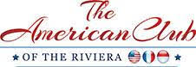

AMERICAN CLUB OF THE RIVIERA
CANNES FILM FESTIVAL LUNCHEON

IN MEMORY OF PRESIDENT EMERITUS BURTON GINTELL

FRIDAY 16TH MAY 2025

CANNES YACHT CLUB

CANNES

SILVER SPONSOR

Special thanks and logo in the American Club of the Riviera Film Festival Luncheon Program

Mention on the American Club of the Riviera Website and Facebook Page as well in the Monthly newsletter

4 complimentary places offered

Euro 4,000.

