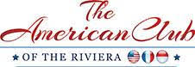

AMERICAN CLUB OF THE RIVIERA
CANNES FILM FESTIVAL LUNCHEON

IN MEMORY OF PRESIDENT EMERITUS BURTON GINTELL

FRIDAY 16TH OF MAY 2025

CANNES YACHT CLUB

CANNES

PLATINUM SPONSOR

Full page advertising in American Club of the Riviera Cannes Film Festival Luncheon Program if requested

Special thanks in the Program

Mention on the American Club of the Riviera Website and Facebook Page as well as in the monthly newsletter

Table of 10 persons offered

Euro 10,000.

